**DAILY ONLINE ACTIVITIES SUMMARY**

|  |  |  |  |  |  |  |  |  |
| --- | --- | --- | --- | --- | --- | --- | --- | --- |
| **Date:** | **26/05/2020** | | | | | **Name:** | **PRANEETA P HANDRAL** | |
| **Sem & Sec** | **4​th​ SEM. & ‘B’ SEC.** | | | | | **USN:** | **4AL19CS401** | |
| **Online Test Summary** | | | | | | | | |
| **Subject** | | **DESIGN ANALYSIS OF ALGORITHMS** | | | | | | |
| **Max. Marks** | | **30** | | **Score** | | | **26** | |
| **Certification Course Summary** | | | | | | | | |
| **Course** | **PYTHON FOR MACHINE LEARNING** | | | | | | | |
| **Certificate Provider** | | | **Greatlearning academy** | | **Duration** | | | **5 Hrs.** |
| **Coding Challenges** | | | | | | | | |
| **Problem Statement**: Write a program in C to print all permutations of a given string using pointers.  Input:  Enter the Input String: abcd  Expected Result:  The permutations of the string are :  abcd abdc acbd acdb adcb adbc bacd badc bcad bcda bdca bdac cbad cbda cabd cadb cdab cdba dbca dbac dcba dcab dacb dabc  **Problem Statement**: Write a JAVA Program to remove all the Tens in the given array | | | | | | | | |
| **Status:** **Executed.** | | | | | | | | |
| **Uploaded the report in Github** | | | | | **Yes** | | | |
| **If yes Repository name** | | | | | **LockdownCoding** | | | |
| **Uploaded the report in slack** | | | | | **Yes** | | | |

**Online Test Summary​:** **18CS42 test was scheduled from 9:15 am to 10:00 am and the test scores is 26 .The portion for the IA was 2nd module there were 30 questions and the time assigned was 45 minutes the questions were mcq type. There were 30 questions of 1 mark respectively.**

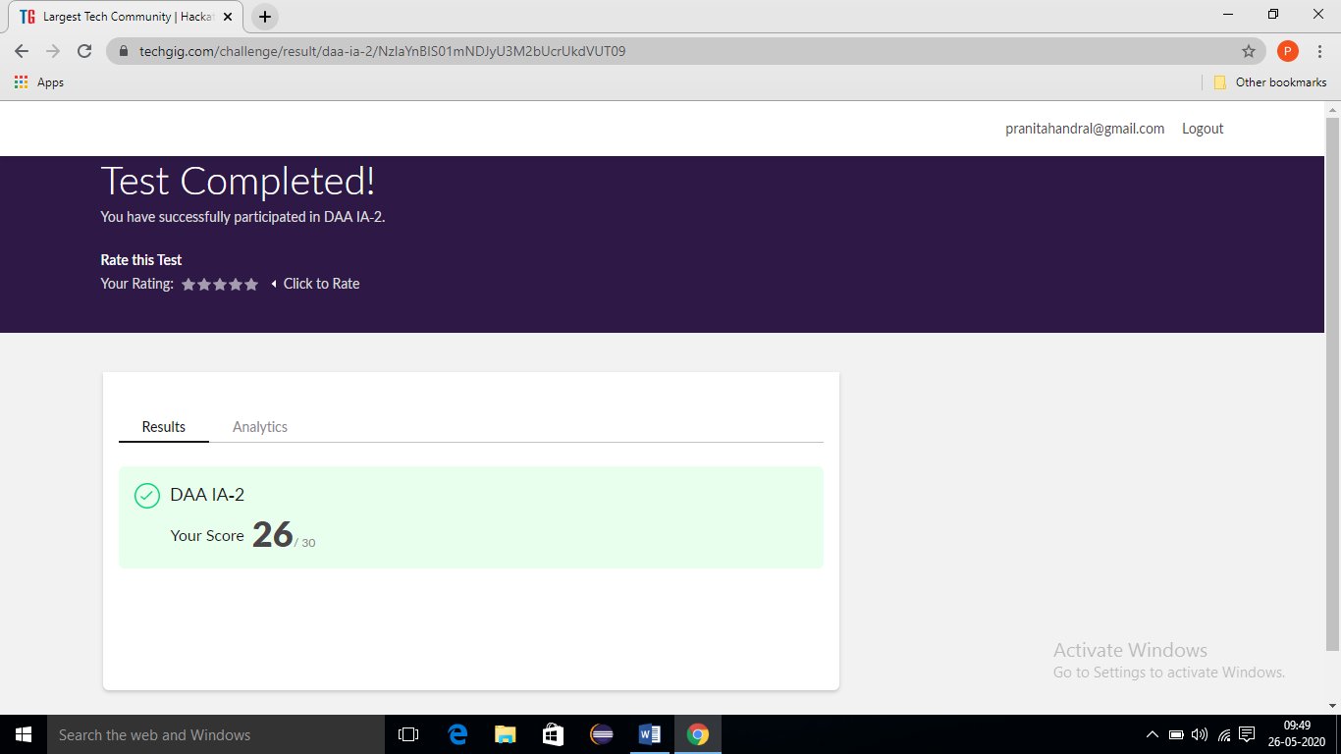

**Online Certification Course Summary​:** **Today I’ve gone through with the steps and completed installation of NumPy in my system. Today I have learn about NumPy and also execute the some of the basic NumPy programs . NumPy, which stands for Numerical Python, is a library consisting of multidimensional array objects and a collection of routines for processing those arrays.  It is shown in the below snapshot.**

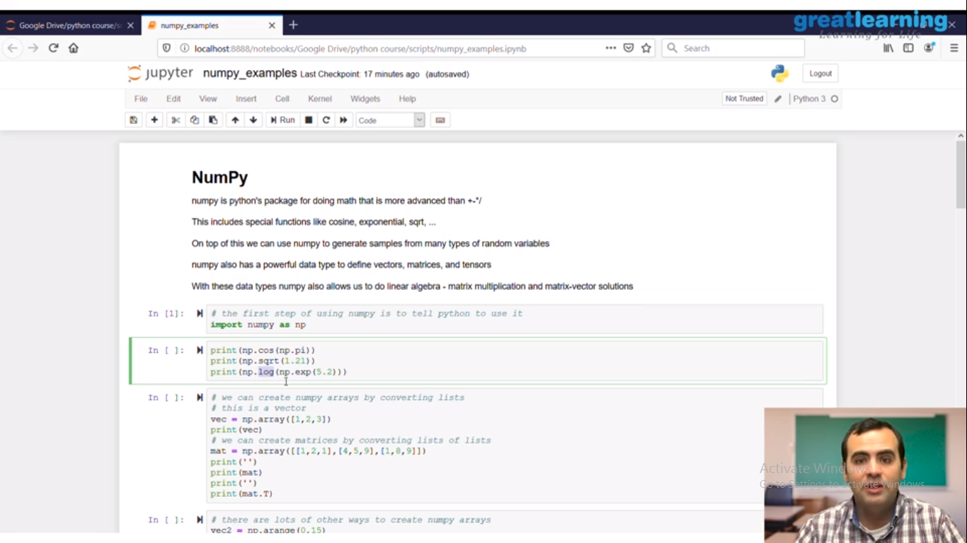

**Online coding Summary:** Today I received two program one from Prof.Venkatesh CSE Dept another one from Prof. shilpa CSE Dept The program is mentioned above. to my GitHub repository and I’ve shared the snapshot below.

